Pseudonym | Date | 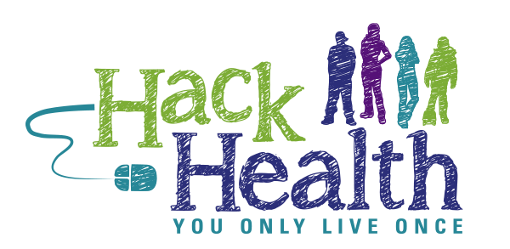
Jasmine’s doctor told her recently that she has type 1 diabetes, but Jasmine doesn’t really understand what that means. She wants to use the Internet to find out, but she doesn’t think she’s very good at using the Internet, so she has asked for your help.
What is Google, and why do you use it?
To get the information she needs, what should Jasmine type into the box on Google?
Jasmine noticed different kinds of websites in the search results. What do these mean:
.com
.org
.gov
.edu
.net
Jasmine wants to know which three of these kinds of websites she can trust the most (circle 3):
.com | .org | .gov | .edu | .net
Explain to Jasmine why you chose these.
Jasmine got millions of results from her Google search. How can she decide which ones to click on?
Jasmine’s teacher told her she should always start looking for information with the links on the school library website. What’s the difference between using the school library site and using Google? Which do you think is better and why?
Jasmine’s teacher also told her that when she uses a website, she should make sure the information is credible. What does credible mean?
Jasmine found this URL: http://webmd.com/diabetes/guide/type-1-diabetes. She’s wondering if the site is related to her topic. How can she tell?
She went to the website, but Jasmine isn’t sure that she can trust the information there. How can she decide?
Jasmine found two sites about type 1 diabetes, but they don’t have the same information. How can she tell which one is right?
What are three health websites you’d recommend to Jasmine?
What should Jasmine do to keep track of the information she’s found about diabetes? Give her three suggestions.
Is there anything else you would tell Jasmine?

